 |  |  |  |  | Status: For Rent  Address: 405 2nd Street  Price: Available for Rental Assistance  Description: The Golden Wheat Village is accepting applications from elderly or disabled persons for a 1 bedroom, 1 bathroom apartment. Rental assistance is available to those who qualify. Applications can be picked up at the Senior Center, City Hall, or Community Development.
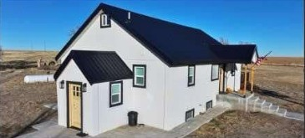 |  |  |  |  | Status: For Sale  Address: 1015 Co Rd. 9  Price: $550,000  Description: New to the market, this combination farm and beautifully remodeled home is located near Tribune, Kansas, and features a 14KW Generac backup generator, powered by a 1000-gallon propane tank. It boasts energy-efficient double-pane windows, a whole-house water filtration system, and R30/R15 insulation. The property includes solid core doors, sound control enhancements, a septic tank, and a well with a 3,850-gallon tank. All Samsung appliances are included. This property is available for sale as a whole, or the cropland can be purchased separately from the grass and farmstead.
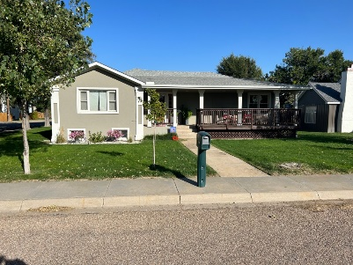 |  |  |  |  | Status: For Sale  Address: 524 Haskell  Price: $240,000  Description: This property is located 2 blocks from the school and 1 block from the west edge of town. Upstairs: 2 bedrooms, 1 office, 1 1⁄2 bathrooms, family room, laundry room, large sitting room open to the dining room and kitchen.  Downstairs: 2 bedrooms (1 bedroom is very large, and the other is non-conforming), 1 bathroom, a family room, and 2 storage rooms. A new high-efficiency gas furnace was installed on 11/14/14. The house's exterior was remodeled in the fall of 2020 with the addition of 2” foam insulation, stucco, new windows, new doors, and the window/door frames, fascia, and soffits were rapped with metal. The house and garage roofs were replaced with high-impact shingles in Aug 2020. The entire yard has an underground sprinkler system. All appliances might stay with the house. Appliance Purchase Dates: Gas water heater 08/16/22 Washer/Dryer 12/21/19 Refrigerator? about 6 years ago, Dishwasher 11/6/2020 Garage A/C Unit 6/21/21 All appliances stay with the house. Garage Info: 3 car garage (24’X42’) The garage is insulated and has heat and air conditioning.
No Picture Available |  |  |  |  | Status: For Sale  Address: 309 Ingalls  Price:$65,000  Description: 3 Bedroom 3 Bath. Oversized attached double garage.
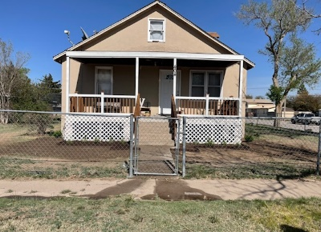 |  |  |  |  | Status: For Sale  Address: 404 Martin Ave  Price: $130,000  Description: 2-story home plus basement. 5 bedrooms (2 on the main floor, 3 in the basement, and there’s potential for 2 more on the top story), 2 bathrooms…. 12 ftx23 ft unattached shed. Newly renovated main floor (creating an open floor concept) and newly renovated porch. The roof and decking were all updated a year ago with high-impact resistant shingles. All appliances are less than 5 years old and will be sold with the house.
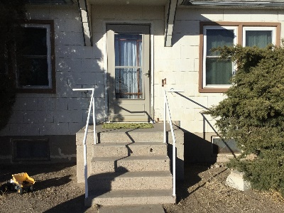 |  |  |  |  | Status: For Rent  Address: Call  Price: Daily Rate $85.00, Weekly Rate Negotiable.  Description: Daily or Weekly Country Rental – Perfect for short term work in the area or hunting. The property is close to Walkin Hunting. Daily Rate $85.00, Weekly Rate $450.00. 2 Bedrooms, 1 ¾ Bath, with primarily 1950’s Décor.
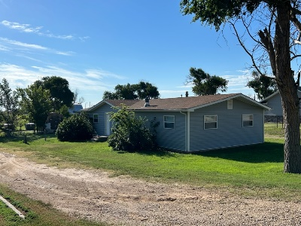 |  |  |  |  | Status: For Sale  Address: 414 4th Street  Price: $80,000  Description: 3 Bed, 2 Bath, 1344 SQ Ft of Living Area. New Roof in 2020, Central AC/Heat Unit replaced in 2021 with a refurbished unit, New windows & siding in 2009, Garden Shed, Fenced in back yard, Handicap Ramp & Shower, Electric Stove & Dishwasher included. House is ready for new flooring to be installed by buyer
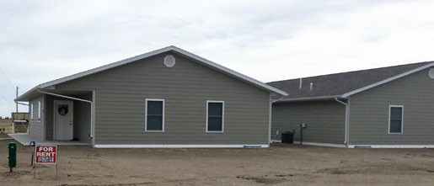 |  |  |  |  | Status: For Rent  Address: Corner of Fourth & Newton Streets, Tribune  Price: $750/month plus $350 security deposit  Description: Newly constructed duplexes, 910 sq. ft. apartments. Each 2 bedroom, 1 bath with kitchen appliances included. Laundry room, tenant provides washer and dryer. Each unit will have a designated covered carport and enclosed storage unit. All yard maintenance and snow removal is included.
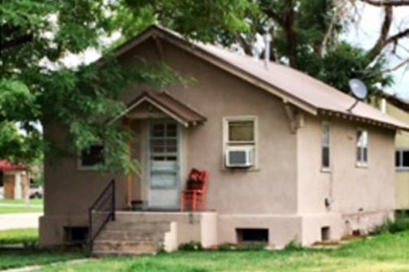 |  |  |  |  | Status: For Rent Address: 624 Peters Price: $600/month  Description: 2 bedroom, 1 bath house located across from the high school, has new cabinets in the kitchen and a basement.
 |  | 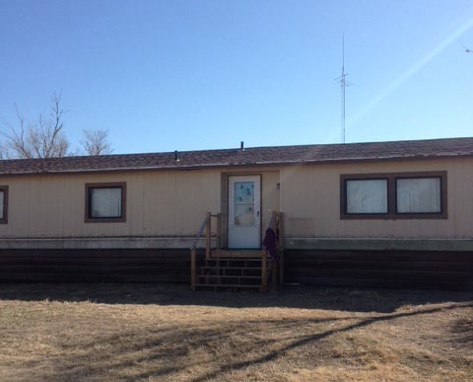 |  |  | Status: For Sale or Rent  Address: Corner of Main and Texas in Horace  Description: Double-wide mobile unit, 3 bedroom, 2 bathroom, Central Air and Heating.
 | 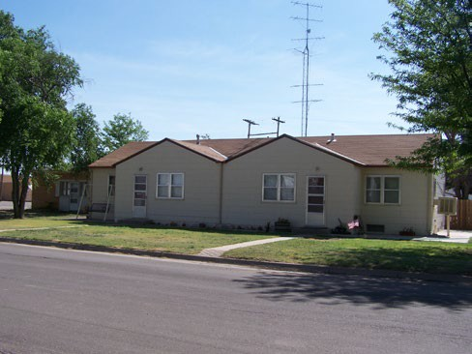 |  |  |  | Status: For Rent Address: 716 Glick  Description: 4 bedroom duplex, close to school
 | 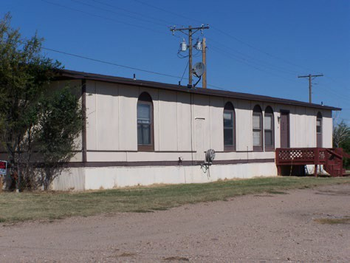 |  |  |  | Status: For Rent  Address: 308 Ohio, Horace, KS  Description: 2 bedroom manufactured home, 1 bath.
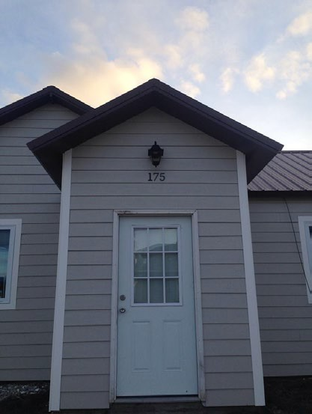 |  |  |  |  | Status: For Sale & Rent Address: 523 Second Street  Description: Multi-family housing unit featuring (2) 1-bedroom finished apartments, and (2) 2-bedroom 1 bath apartments. The south apartment is a one bedroom, one bath apartment with a full kitchen, a storage lean-to, and a washer and dryer combo. The middle apartment is a one bedroom, ¾ bath apartment which has been plumbed for a washer and dryer. This apartment also features access to a large basement for storage. The two north units are 2-bedroom, 1 bath units and have all utilities paid.

AVAILABLE LOTS

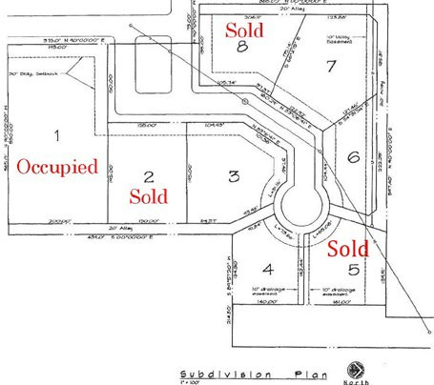 |  |  | Status: For Sale  Address: White Woman Creek Addition  Description: White Woman Creek Addition residential lots for sale. Call for more details.
 | 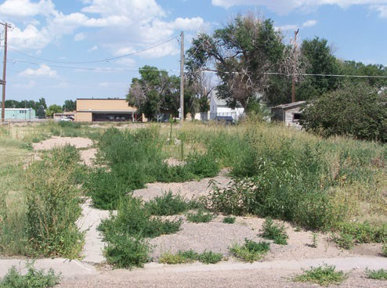 |  | Status: For Rent or Sale Address: 718 Haskell  Description: Mobile home space

